
Karakia

Te Kākano
Te Aroha
Te Manawa ngā taonga
Ko ngā mokopuna
Kotahitanga
Te kaha o te whānau

Here lies the seed of Playcentre
With warmth and sharing
Love, caring give the seed growth
The heart of the seed is the children
The strength is the family drawing together
In unity and learning

Gifted to Playcentre by life members of the Hutt Association
by Papa Hepetema Taitua and Whaea Mate Taitua
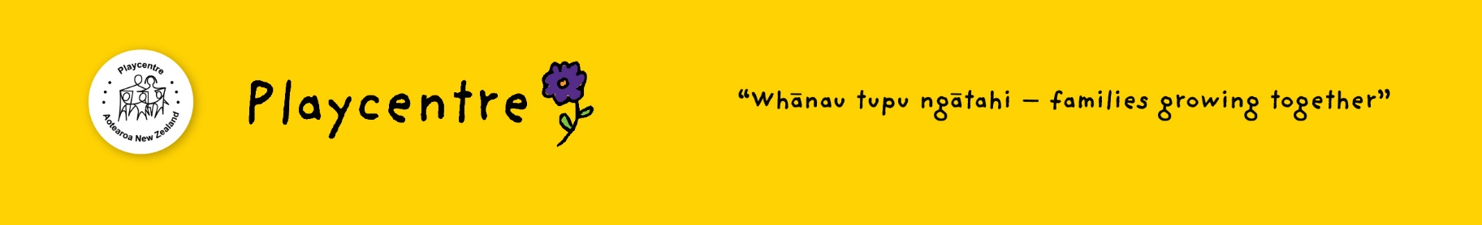
(Tune: You are my sunshine)

